**MODULE – 4 ASSIGNMENT**

**Functions**

**Please write Python Programs for all the problems.**

1. Write a Python function to find the Max of three numbers?

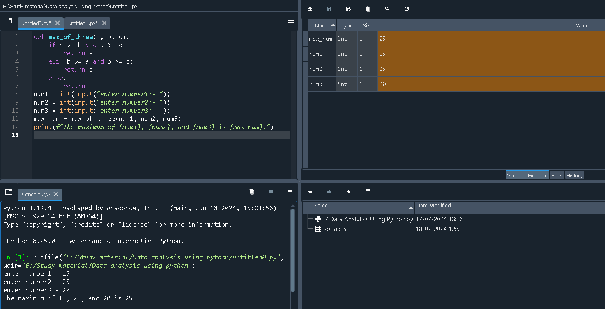

1. 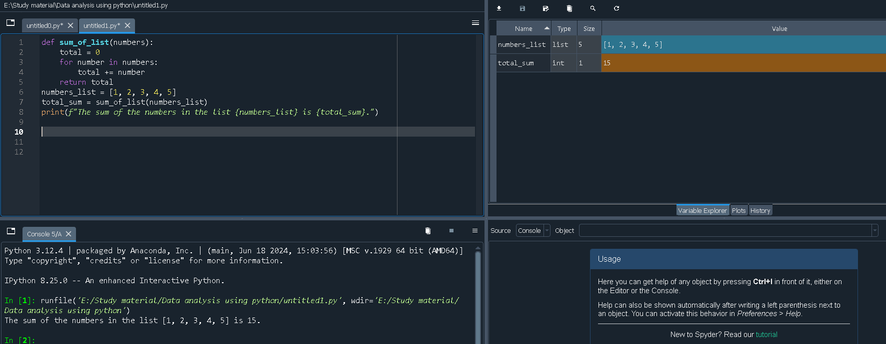 Write a Python function to sum all the numbers in a list?
2. Write a Python function to multiply all the numbers in a list.

